# **Name: Abdurrahman Qureshi**

# **Roll No: 210451**

Practical No: 7

**1) Write a program to use all form events**

**CODE:**

<html>  
<head><title>EXP7A</title>  
<style>  
 div{  
 display: flex;  
 align-content: center;  
 margin: 1rem; }  
 h2{  
 width: 50%;}  
 input{  
 width: 20%;}  
</style>  
</head>  
<body>  
<h1>EXP7A</h1>  
<form name="form1" onsubmit="submitEvent()">  
 <div>  
 <h2>onFocus & onBlur: </h2><input type="text" id="text1" onfocus="focusEvent()" onblur="blurEvent()"><br><br>  
 </div>  
 <div>  
 <h2>onChange: </h2><input type="text" id="text2" onchange="changeEvent()">:  
 <input type="text" id="text21"><br><br>  
 </div>  
 <div>  
 <h2>onClick: </h2><input type="button" id="btn1" value="Click me" onclick="clickEvent()"><br><br>  
  
 </div>  
 <div>  
 <h2>onMouseOver: </h2><input type="text" id="text3" value="Old Text" onmouseover="mouseoverEvent()"  
 onmouseout="mouseoutEvent()"><br><br>  
 </div>  
 <div>  
 <h2>onKeyUp & onKeyPress: </h2><input type="text" id="text4" onkeypress="keypressEvent()"  
 onkeyup="keypupEvent()"> ------  
 <input type="text" id="text41"><br><br>  
 </div>  
 <div>  
 <h2>onMouseUp & onMouseDown: </h2><input type="text" id="text5" onmouseup="mouseupEvent()"  
 onmousedown="mousedownEvent()"><br><br>  
 <input type="submit" id="submit" value="Submit">  
 </div>  
</form>  
<script>  
 var ***a*** = 0, ***b*** = 0;  
  
 function focusEvent() { ***document***.getElementById("text1").style.boxShadow = "7px 7px 10px red";}  
 function blurEvent() {  
***document***.getElementById("text1").style.boxShadow = "7px 7px 10px black";}  
 function changeEvent() { ***document***.getElementById("text21").value = "Text changed " + ++***b*** + " times";}  
 function clickEvent() { ***document***.getElementById("btn1").value = ++***a*** + " times clicked";}  
 function mouseoverEvent() {  
***document***.getElementById("text3").value = "New Text"}  
 function mouseoutEvent() {  
***document***.getElementById("text3").value = "Old Text"}  
 function keypressEvent() { ***document***.getElementById("text41").value = "Key Pressed"}  
 function keypupEvent() { ***document***.getElementById("text41").value = "Key Released"}  
 function mouseupEvent() { ***document***.getElementById("text5").value = "Mouse Up"}  
 function mousedownEvent() { ***document***.getElementById("text5").value = "Mouse Down"}  
 function submitEvent() {  
 alert("Form Submitted.") }  
</script>  
</body>  
</html>

**OUTPUT:**

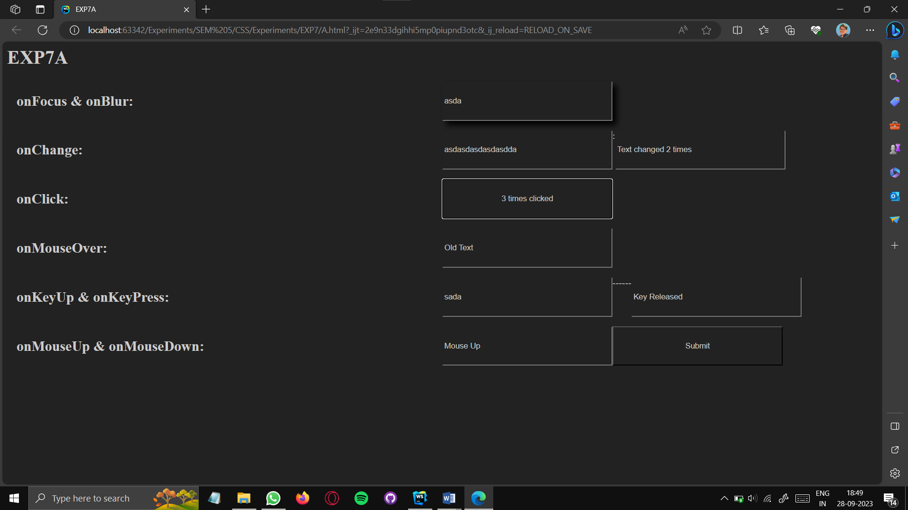

**2) Write a program to create multiple forms in a single web page**

**CODE:**

<html>  
<head><title>EXP7B</title>  
 <style>  
 input{  
 width: 30%;  
 height: 10%;  
 font-size: 3rem;  
 }  
 </style>  
</head>  
<body>  
<form name=from1 style="background-color: hotpink;">  
 <input type="text" placeholder="Text Box"> <br>  
</form>  
<form name=from2 style="background-color: darkgoldenrod;">  
 <input type="password"/><br>  
</form>  
<form name=from3 style="background-color: limegreen;">  
 <input type="date"/><br>  
</form>  
<form name=from4 style="background-color: magenta;">  
 <input type="checkbox"/> Form Checkbox<br>  
</form>  
<form name=from5 style="background-color: sienna;">  
 <input type="color"/><br>  
</form>  
</body>  
</html>

**OUTPUT:** 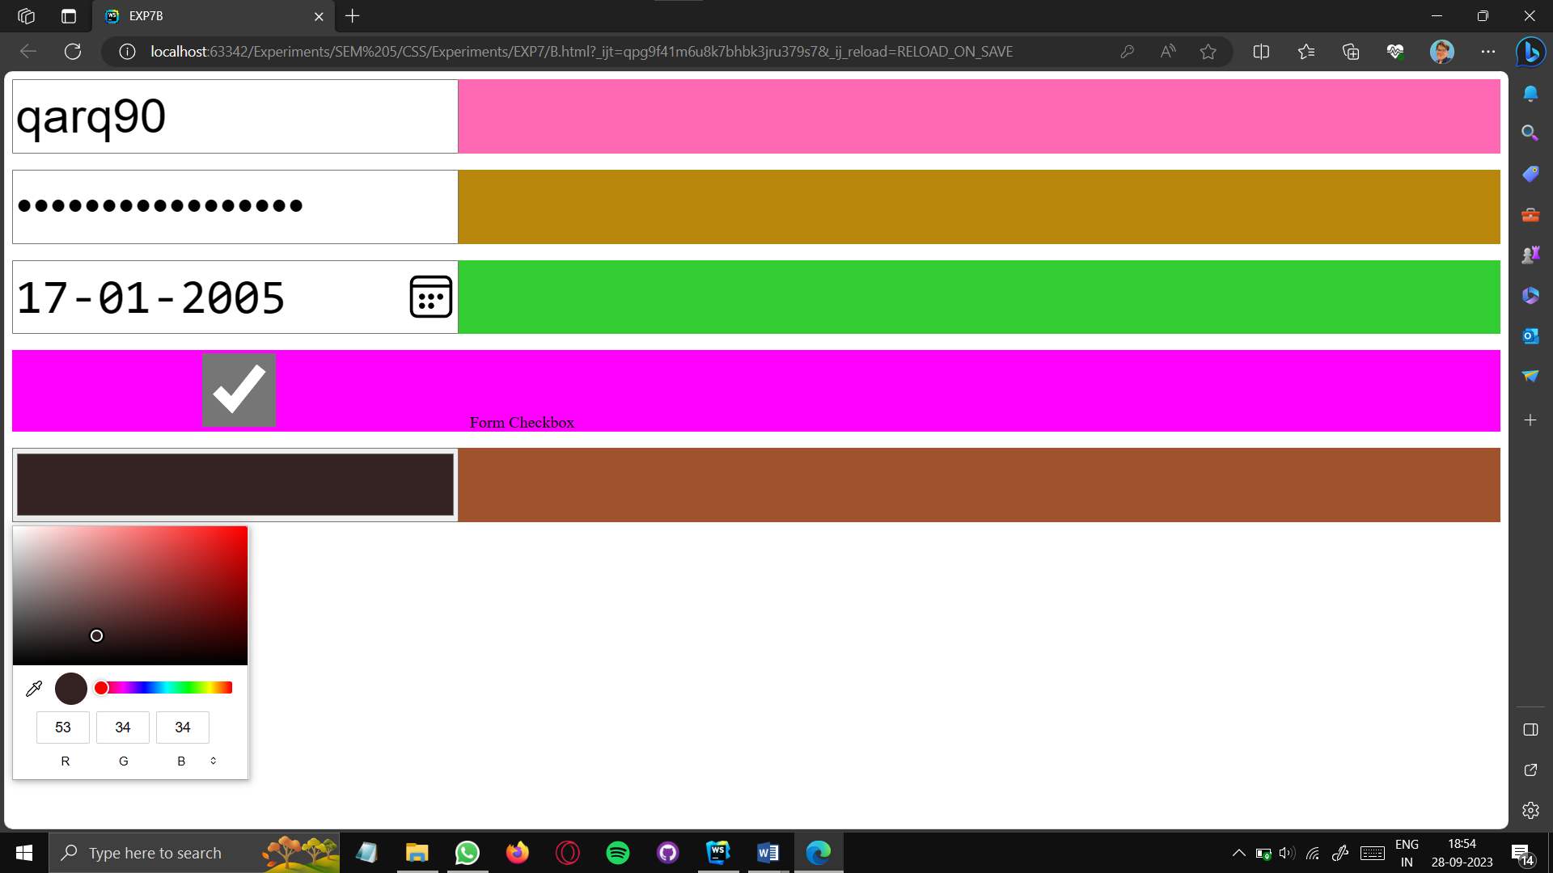

**3) Write a program to change HTML element’s attribute dynamically.**

**CODE:**

<html lang="">  
<head><title>EXP7C</title>  
<style>  
 body{  
 font-family: sans-serif; }  
 input{  
 width: 10%;  
 height: 10%;}  
</style>  
</head>  
<body>  
<h1>EXP7C</h1>  
<form name=form1>  
 What is your attribute name: <input type="text" name="text1">  
 <h3>Click the button below to set the attribute</h3>  
 <input type="button" value="setAttribute" id="btn1" onclick="clickEvent()"><br>  
 <script>  
 function clickEvent() {  
 var a = ***document***.getElementById("btn1");  
 if (a.value == "setAttribute") {  
 a.setAttribute("name", "Spectre Scythe");  
 a.setAttribute("value", "removeAttribute");  
 } else if (a.value == "removeAttribute") {  
 a.removeAttribute("name");  
 a.setAttribute("value", "setAttribute");}  
 ***document***.form1.text1.value = a.getAttribute("name");}  
 </script>  
</form>  
</body>  
</html>

**OUTPUT:**

